2021 KINGBOROUGH ART PRIZE – CONDITIONS OF ENTRY

- Entries are not valid without a completed entry form received by the closing date of Monday 8th February 2021.
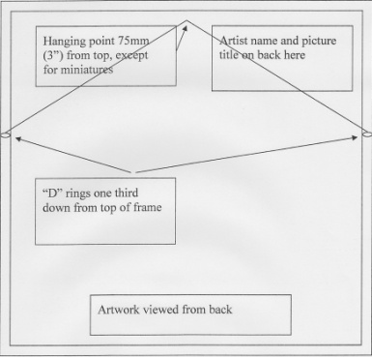
- All picture artwork to be mounted and wired for hanging, with the KAP Receipt number for this piece of Artwork, title and artist’s name affixed to the rear upper right corner (see diagram).
- UNSIGNED ARTWORK/S CAN NOT BE ACCEPTED.
- Clip frames not accepted.
- No copies or wet artworks will be accepted.
- Artists may enter up to 3 works, except for Ceramics and Jewellery, which can be up to 8 pieces.
- All artworks are eligible for the Kingborough Art Prize.
- All entries must be the original work of the artist, and not exhibited previously at KAP Exhibitions.
- Max. size limit is strictly 1.5 metres on any one side, inclusive frame
- The organisers reserve the right to not exhibit an artwork.
Ensure KAP Receipt # is also in top right-hand corner.
- All entries must be for sale and may be used for promotional and archival purposes.
- A commission of 25% will be charged on all sales. Please allow for the commission when pricing your artwork.
- The judge’s decisions are final, and no correspondence will be entered into.
- Entries to be delivered to Kingston Beach Hall, 20 Beach Road, Kingston Beach between 9:00am - 3:00pm on Tuesday 16th February 2021.
- Freighted entries must include pre-paid return freight. Recommended courier is Fastway.
- Unsold works must be collected strictly between 4:00 - 6:00pm Sunday 21st. February 2021. Artworks may not be removed from the exhibition before 4:00pm.
- There are no facilities for post exhibition storage, therefore, artworks not collected by the above deadline will become the property of the Lions Club of Kingborough and may be sold for charity.
- The organisers will take every care with all artworks but will not be held responsible for damage, loss or theft of any item in the exhibition. Artists are advised to insure their own artworks.
- In special circumstances, sold artwork/s can be removed from display, prior to the closure of the exhibition.
- Although the exhibition is open to the public from 10am on Friday 19th February , there will be no official opening in 2021 due to Covid restrictions.
- The exhibition is open to the public 10:00am - 8:00pm Friday 19th February 2021, 10:00am – 5:00pm Saturday 20th February 2021 and 10:00am-4:00pm Sunday 21st February 2021.
- Entry forms are available at www.kingboroughartprize.org
- For more information call Helen on 0448 160 751 or email kingboroughartprize@gmail.com

OneDrive/Lions/KAP2020/Artist Communications/2020 Conditions of Entry.docx

